**lntraweek Market Reversals & Overlapping Models**

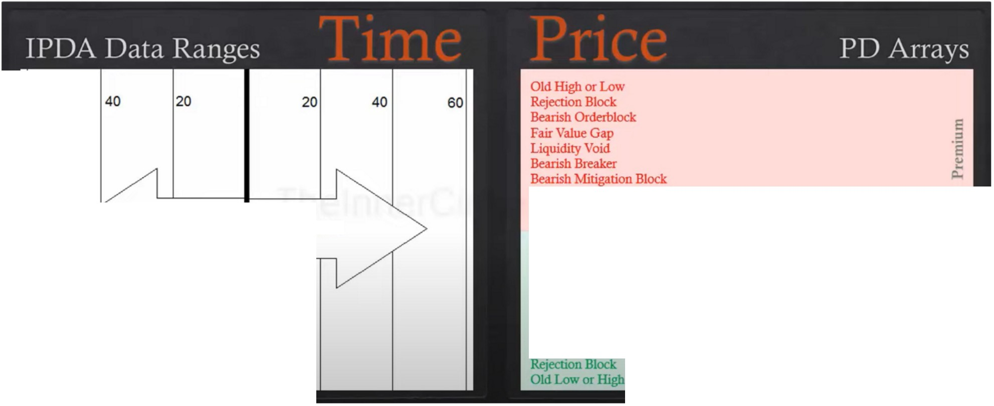

60

Look Back Cast Forward

**Mar1<et Price**

Bullish Mitigation Block Bullish Breaker Liquidity Void

Farr Value Gap Bullish Orderblock

**PD Array Matrix**

The hardest thing to teach for ICT is the market reversal profile

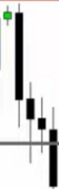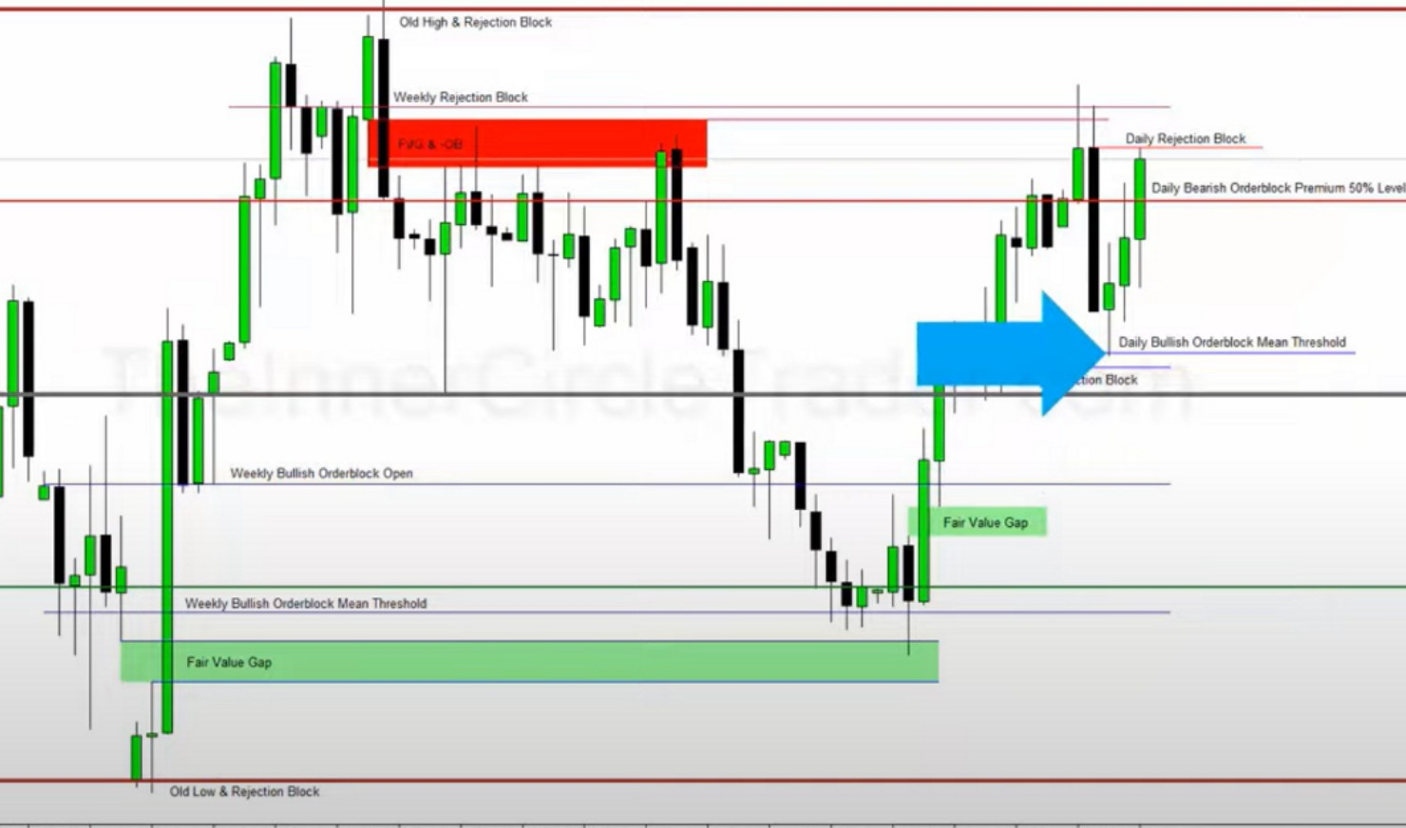

•

l!jl!

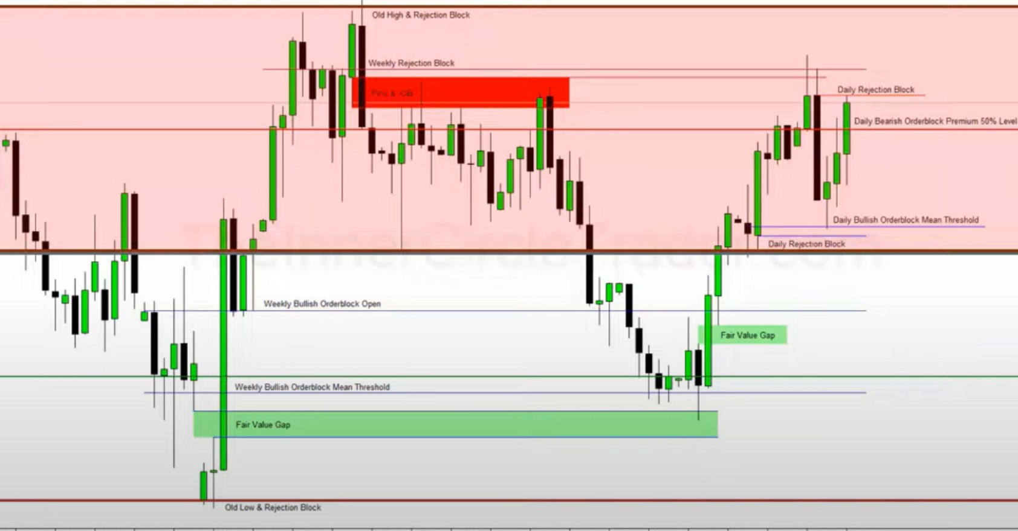

•

When we see a fast market, we immediately assume that theyre reaching for a level of institutional orderflow thats highly efficient, that might be in the form of commerce globally or repricing on the central bank level

Blending all timeframes comes with experience

Having a well rounded approach with multiple timeframes, you will by default be better at someone that only focuses on 1 timeframe.

**Price Unwilling To Leave Premium**

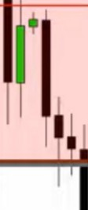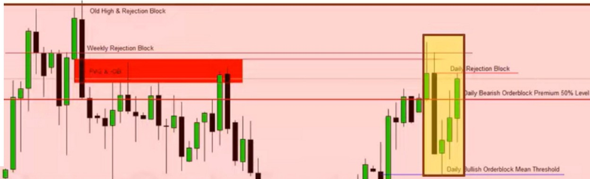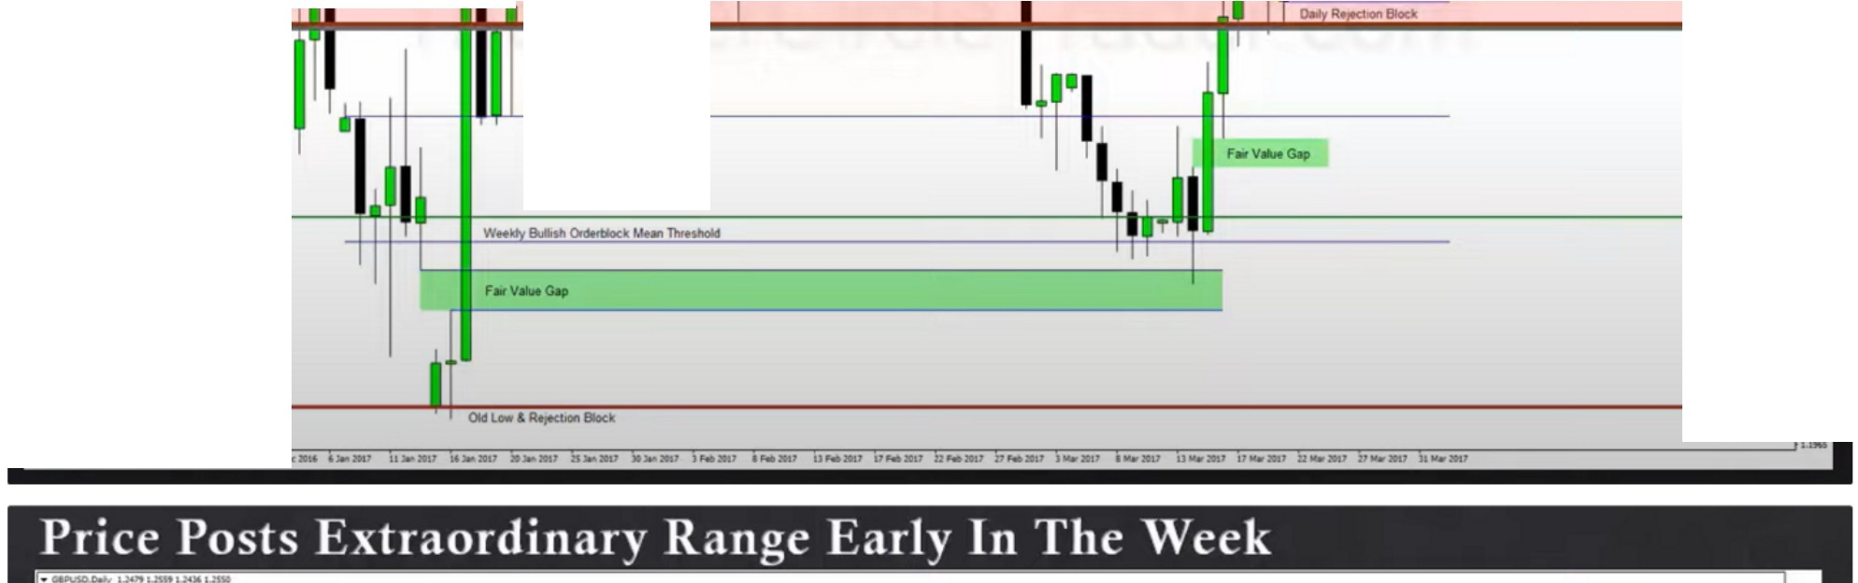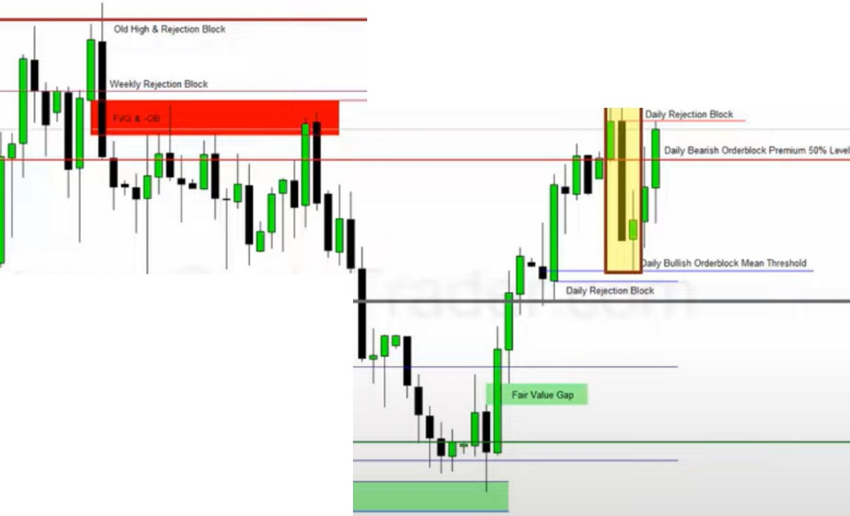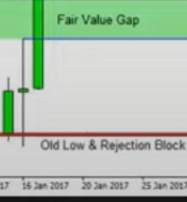

·1111!

**WMldyaAlll0Nlrtllllld;0,.**

•

**·1**

I

I

1tli!

**&6'tlCWlttllKkMunnw....**

•

|  |  |
| --- | --- |
|  |  |
|  |  |
|  |  |

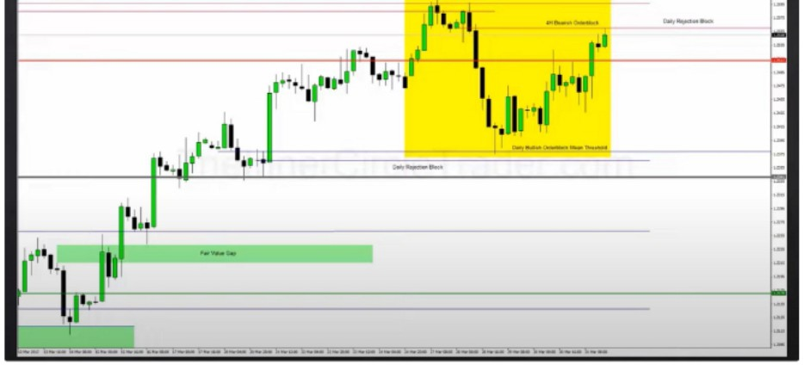**uh Th, Ldr t Dulmt From Tht Fn,;t Of Tiu Wuk**

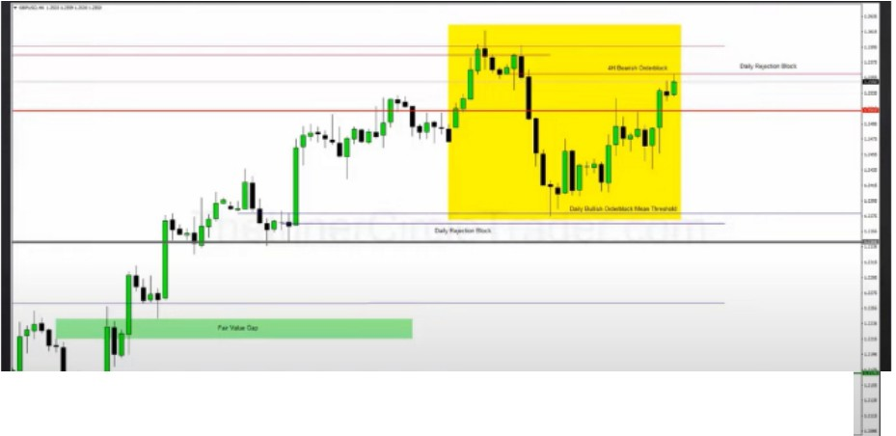

**1-1,1'··**

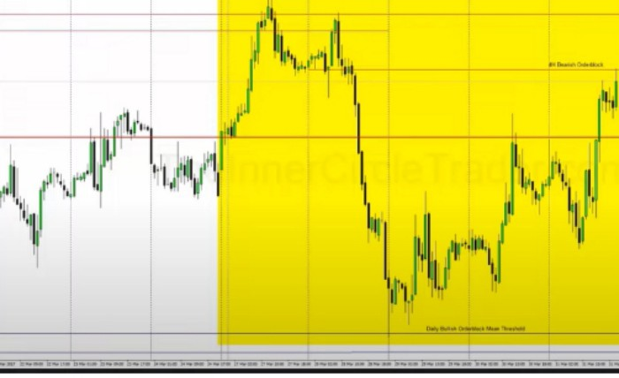

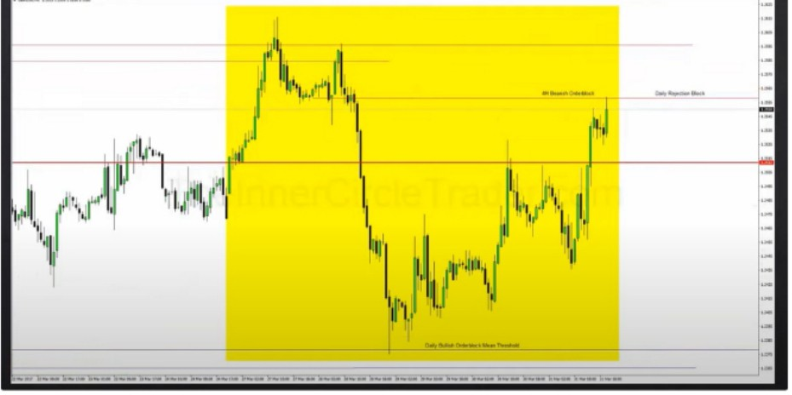

This is the classic sign that we'll have a intraweek reversal

Everytime monday and tuesday start trading aggressively thats usually telling you its in a hurry to make the weekly range, or its going to go to an institutional orderflow reference point that could cause it to reverse and go the other way

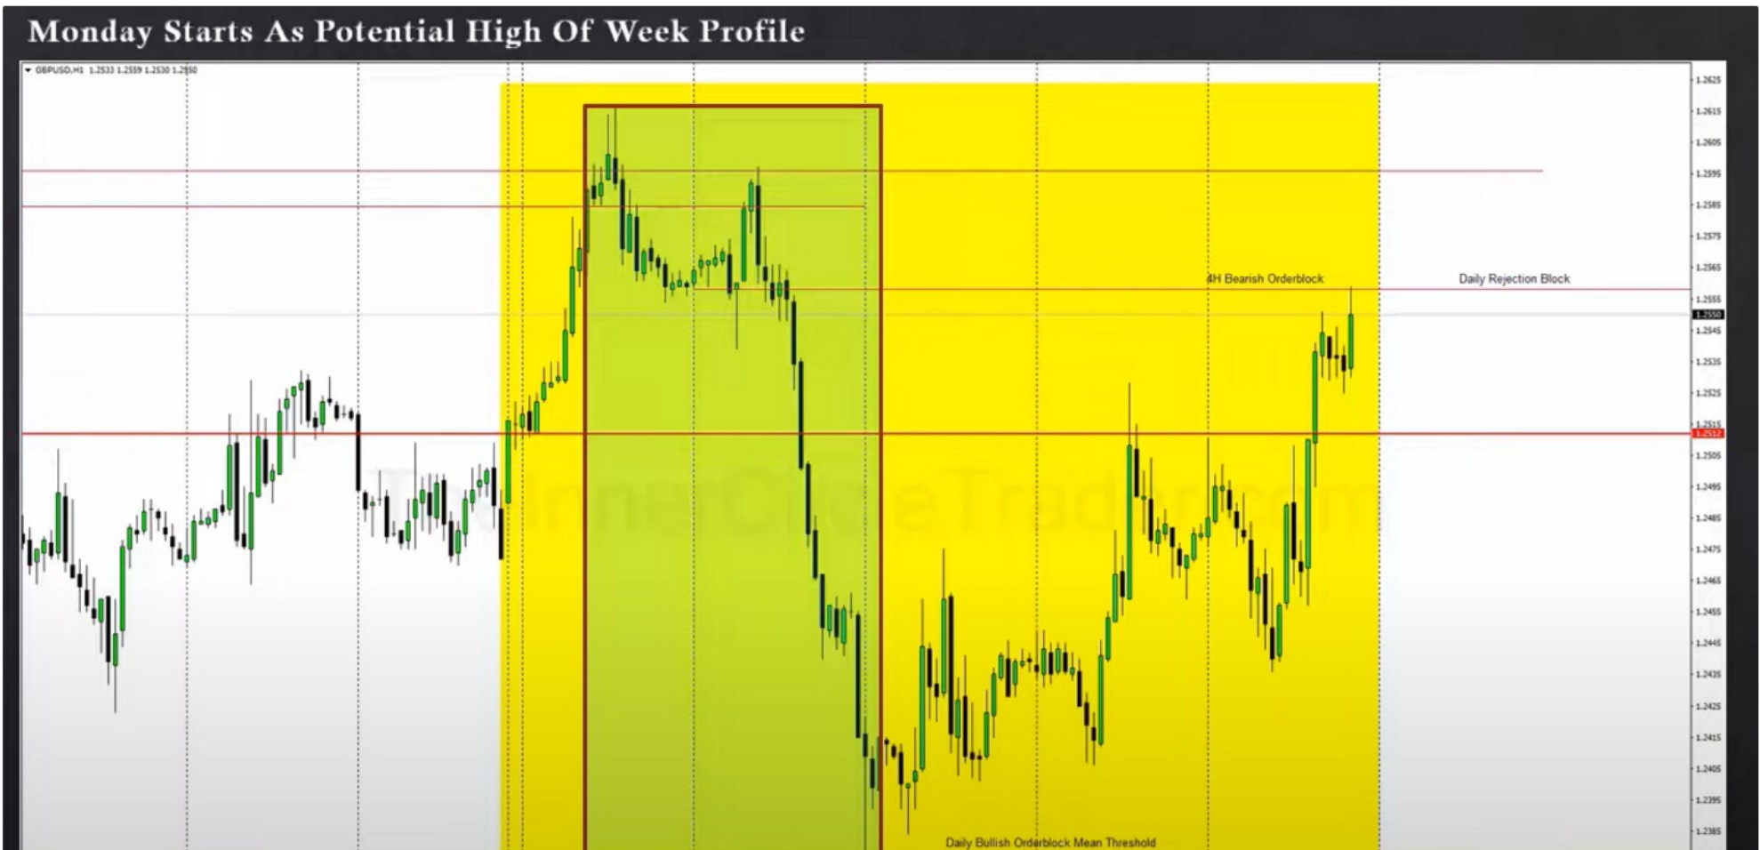

Were covering a lot of ground in the beginning of the week, whenever that happens you immediately look at HTF PD arrays where it could reverse

Speed in price is indicative of them getting to a valuation point. When price is in a hurry to get somewhere its repricing on a central bank level, that repricing is a response to a central bank intervention or interest rate announcement. When theres neither of that then thats based on speculation.

While were in a premium market, the market shows its not willing to go out of the premium market.

And we came into a short term discount in a quadrant

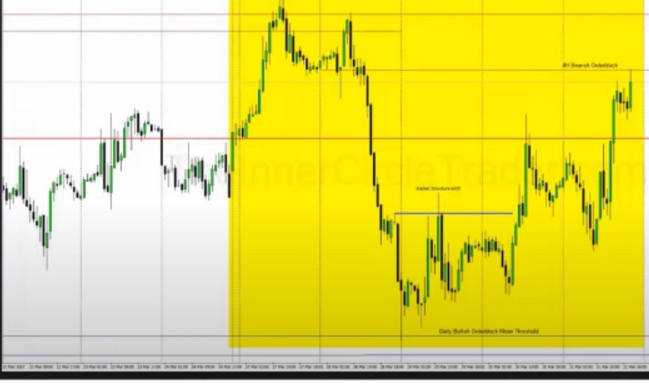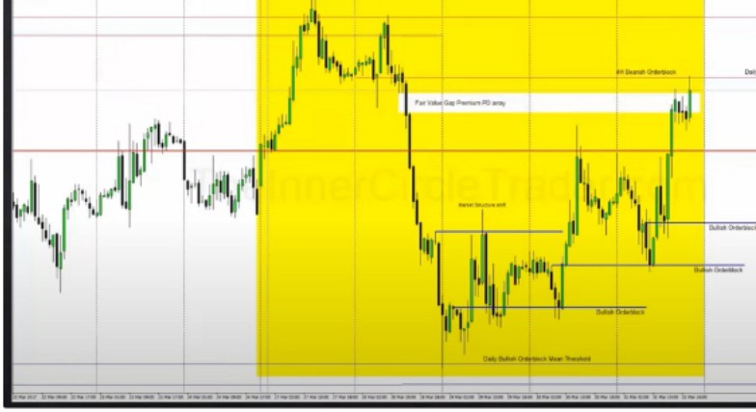

|  |  |  |  |
| --- | --- | --- | --- |
| ---  -  **11**·**,t**"**.L**''  **P:wV""""G.flCl POan--r**  I | | | |
|  | |  | |
|  |  | |  |
|  |

This could end up becoming a market maker buy profile

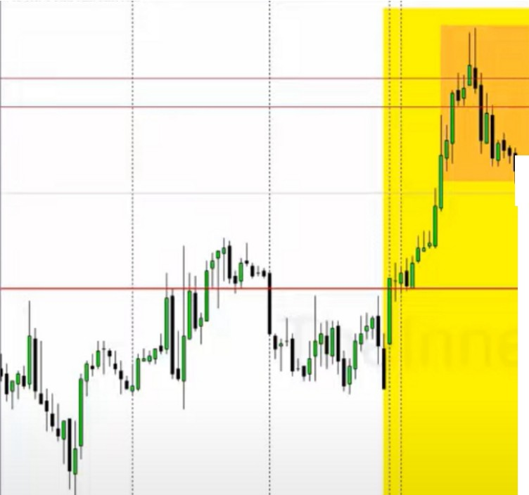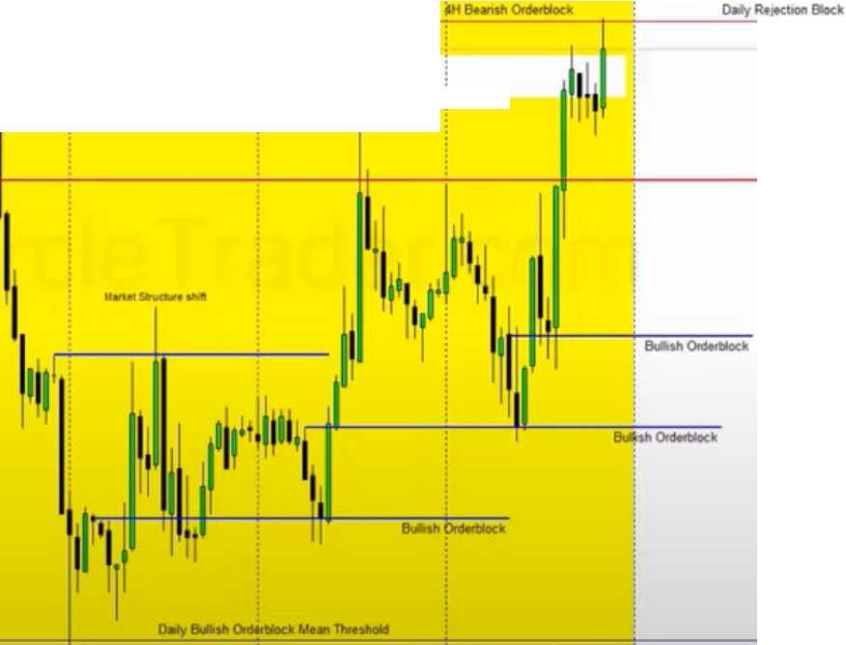

**lntraweek llen·rs,ils Will** I **ook l'o Return To The l'revious Bal.1nn·d l'rfre ll.mj!e Or Exceed** It

* **-I-ZUIUllfl..llll**

!

'

*J----*

IJIi111,,,,,,i;l,11 ,.+-·-

.1111'

-

-

-

**AtJKt,o,,et.ck**

**11** I'''**tii'jl**'**l**

111,1 i

1,111lli•11I

I

!,,'11,l,n1,I,I11,jl'

11 -·--

1111' ,

t,

I

Ijl1,11 ii

1!1

1

'

11•,, I'll'

IP\I

II

·'1

i

'

I

....,, ,.

**!0-..CII**

'

**a.1110,111••-0,....,** !

--·

!

'

'

'

'

*u_.., 11--* ***a.... ,_* u ..... D-- D....lHI** ,. ...... ,.._.. ,....,_ *u._... 1'-- 11--* ·-- ·-- ·-- ,,._.. **z,-- *n--***·-- ·--·--JI-- II--·--

'

-=

--

--

--

-**•M**

-'""

--

**e**

·--

--

-=

--

This can be the end of the move, but it can be likely that we exceed that price range and take those highs

If monday and tuesday or 1 of the 2, moves fast and magnitutes. If it exceeds the average range of the last 5 days chances are you might see an intraweek reversal, not always but you have to consider it.

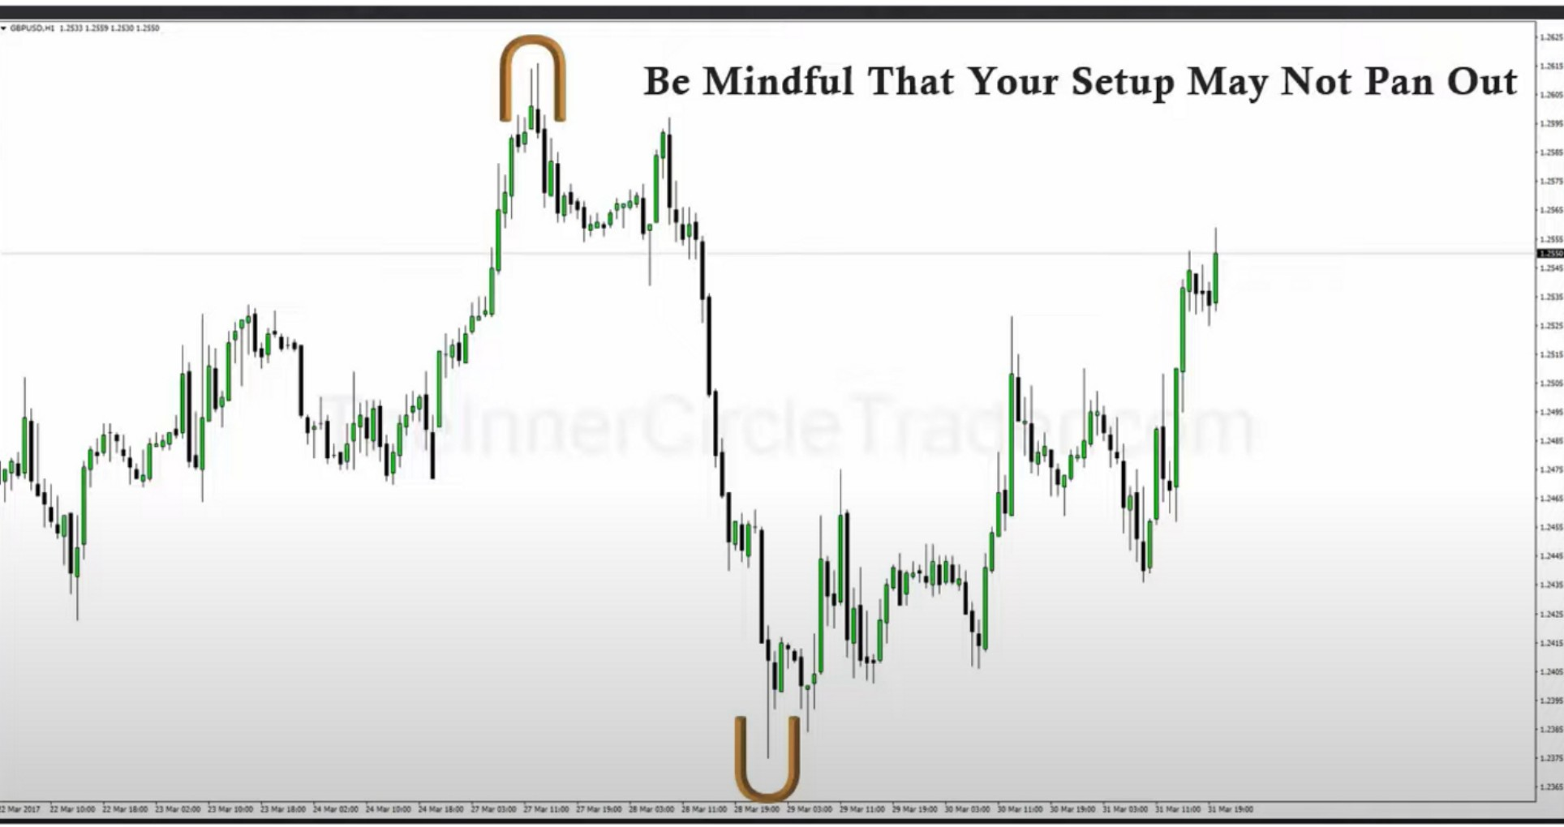

At the beginning of the week we always anticipate the high or low of the week, thats a general concept in ICT for all profiles

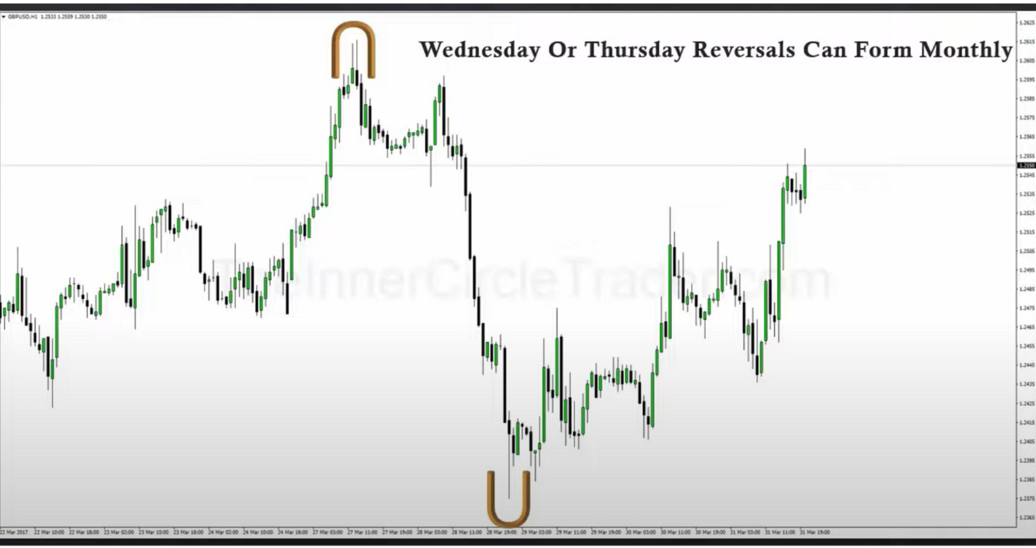

|  |  |
| --- | --- |
| ._. ,UOJ'J,.-uo•1.-  *i* 11,,I J.  I r1 I  jj 1111,, 1 11! 11n 11  11l !1,,J1  ,t **Consider Swing Trading Model Overlap Possibilities** | ·-  -=  ·--  I::"  ·---  --  -=  -  -=•  -=•  ···---  ·- |
|  |

If you only focus on being 1 kind of trader, then youII miss these potential reversal

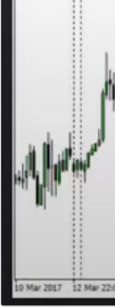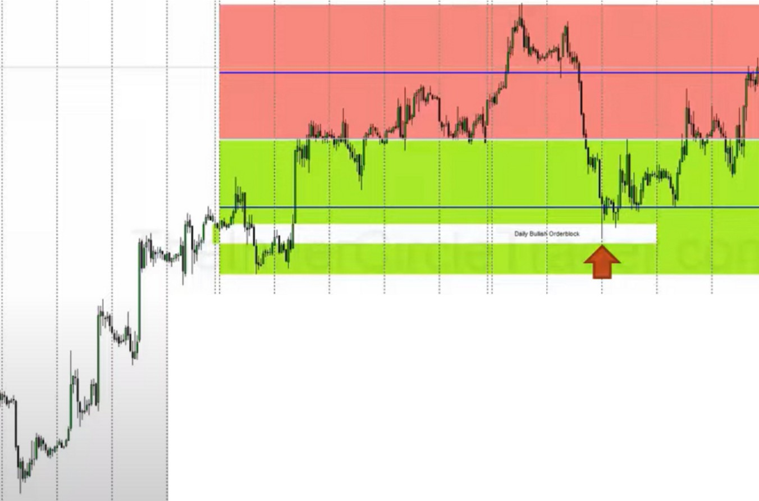

l

II

l

:

**Reversals lntrawee;k Occur** I **Overlapping Models**

Every intraweek reversal will be overlapping of 2 types of models, the HTF model will always win. Thats why we focus on monthly week and daily PD arrays anything less than that, 4h is about as low as you want to go. Anything less than that is all daytrading stuff and if the day trading PD arrays are not in aligment with the HTF PD arrays you're really not trading high probability setups

By blending the models you have a greater view of price action, if swing trading says its a buy and one shot one kill wants to sell chances are the swing model will win and you might want to rethink the one shot one kill

So

1. fast movement on monday and or tuesday, the magnitude at which it moves
2. look for overlapping models, the HTF model will always win

Arjo I Twitter, lnstagram I Linktree

Linktree. Make your link do more.

1 https://t.co/HhmmTN1fUI

JavaScript is not available.

*"11* https://twitter.com/arjoio